Matthew Romleski

TechID 12676184

Homework #1

Problem #2)

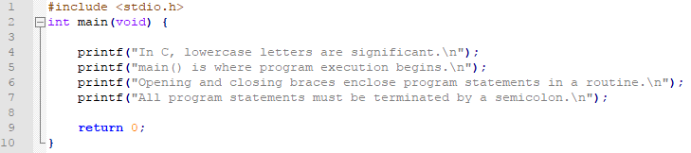

Problem #4)

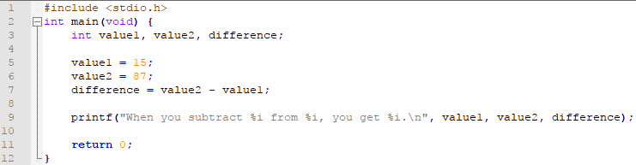

Problem #5)  
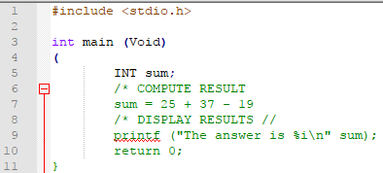

* Line #3: Void should not be capitalized.
* Line #4: Parentheses is used instead of curly bracket.
* Line #5: INT should not be capitalized.
* Line #6: Comment is not closed with \*/
* Line #7: No semicolon at the end of the line.
* Line #8: Comment is closed with a // instead of a \*/
* Line #9: Missing a comma between the quotation mark and “sum”.

A working version of the program:  
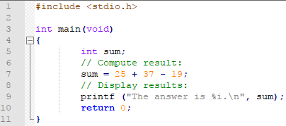

Problem #6)

The output of the program should read as follows:

The result is 95